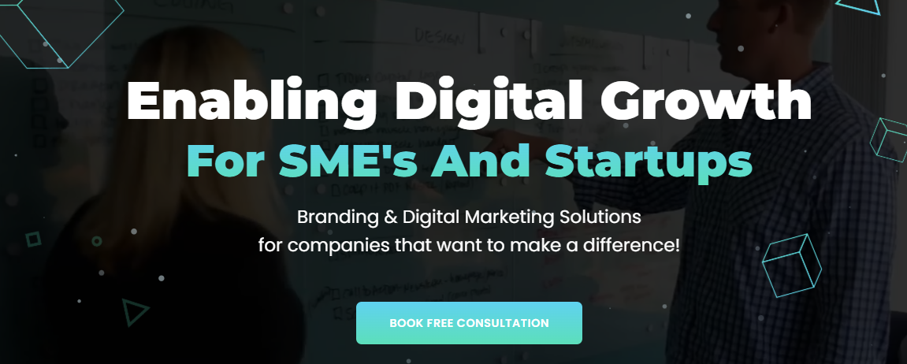
Headline:
"Transform Your Business with Expert Web Development & Automation Solutions"
Subheadline:
"From eCommerce automation to custom website design, we empower your brand to thrive in the digital world."
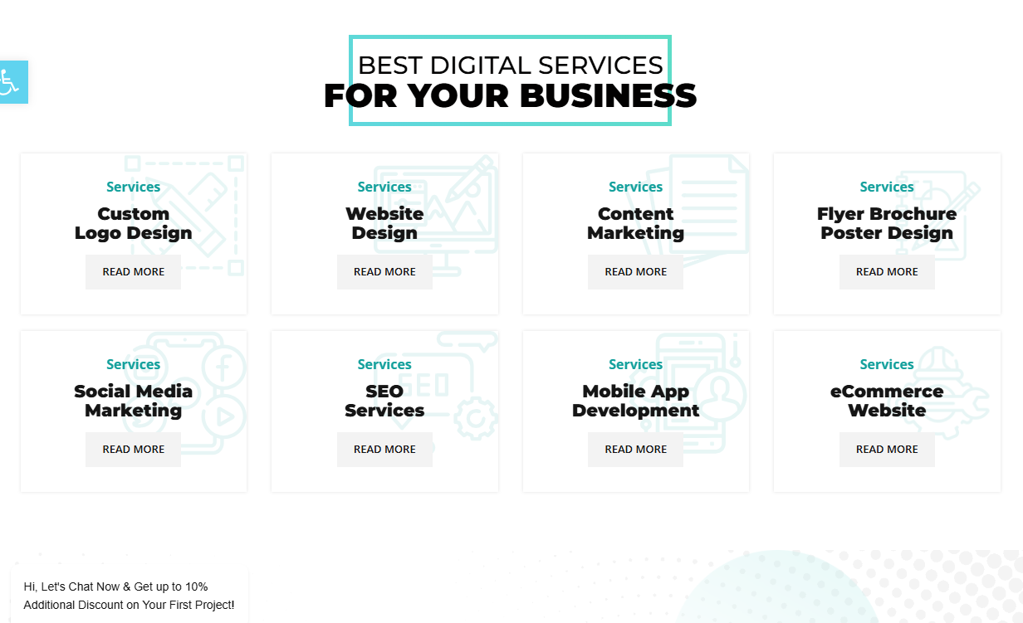

Best Digital Services for Your Business
Let our digital solutions help your business flourish - eCommerce automation, web design and social media marketing among them - we deliver new services that yield results and ensure growth for you and your organization.
Amazon FBA Automation
Unlock the potential of your Amazon store with our complete Amazon FBA automation. Take the stress out of inventory management, order fulfillment and pricing allowing you to focus on expanding your business instead.
Walmart WFS Automation
Make managing your Walmart operations simpler with our WFS automation solutions, from optimizing listings to managing orders - all designed to increase sales while decreasing expenses.
YouTube Automation
Expand your channel easily using our YouTube automated tools. Automate uploads of content, schedule posts and engage with viewers - all to increase revenues while growing your channel.
Shopify Automation Enhance the performance of your Shopify store using automated tools that manage everything from inventory management to customer communication and increase efficiency and sales.
TikTok Shop Automation
Automate your TikTok shop using our tools designed to streamline product listing, order management and customer interactions for maximum sales growth while streamlining processes.
Amazon Store Management
Let us relieve the burden of managing and overseeing your Amazon store with professional solutions such as optimizing product listings, marketing management and sales analytics to aid growth of your store.
TikTok Shop Profit Calculator
TikTok Shop Profit Calculator assess the profitability of your TikTok shop using our Profit calculator. Monitor costs, calculate profit and make informed decisions to drive business performance forward.
Amazon Shop Profit Calculator
Use the Amazon Profit Calculator to analyze your store's profit margins on Amazon. Track revenue, costs and expenses and pricing strategies; additionally optimize these strategies for maximum return.
Website Design Services
Make an impactful online impression with our custom web design and development services, crafted to enhance user experience while simultaneously improving SEO. We deliver beautiful yet responsive sites designed to improve both these aspects.
Graphics Designing
Enhance the image of your brand through our graphic design services. From logo creation and marketing collateral design, to website and digital graphic designs - we help your company create visuals that represent it accurately.
Social Media Marketing
Expand your reach by taking advantage of Social media's marketing solutions. Our strategies are custom tailored to reach out to target viewers, increase followers and boost sales on platforms like Facebook, Instagram and LinkedIn.
Search Engine Optimization (SEO)
Improve your website's presence online by employing our Search Engine Optimization (SEO) services. We utilize proven strategies and methodologies that will increase organic visitors by ranking higher on search engines - giving your website maximum exposure on the Internet!
Content Marketing
Engage and inform your customers by employing our strategies for content marketing. Our teams create engaging material that draws traffic, builds trust, and contributes to meeting business objectives.
PPC
Enhance the return on your investment with our PPC Management services, designed to maximize return. We create targeted campaigns that generate traffic, leads and sales all while staying within your budget.



Our Clients: We’re Proud to Work For
We collaborate with innovative businesses that trust us to drive their digital success. Join the ranks of our satisfied clients and let us help you achieve your goals!


Introduce Your Brand to Digital Media!
Unlock your brand's true potential by stepping into the digital world. Our creative digital services help you stand out, capture attention, and shine alongside top industry leaders.
Join 200+ Satisfied Clients Who’ve Already Taken Their Business to New Heights with Us.


What Drives Us to Excellence
At UK Web Developers, our drive for excellence stems from a passion for innovation and delivering results. Our mission is to push the boundaries of digital technology, providing solutions that transform businesses and set new industry standards.
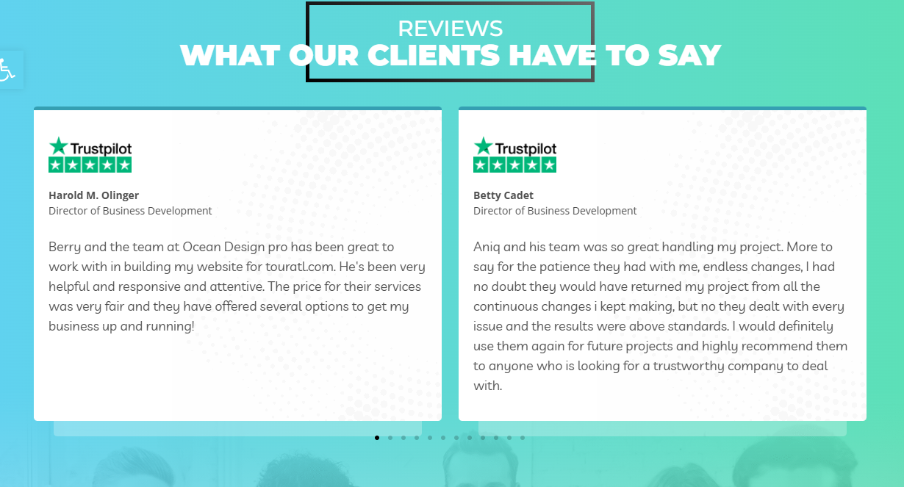

Client Testimonials: Hear What Our Satisfied Clients Have to Say

John T.
UK Web Developers' Amazon FBA Automation services were absolutely transformative for our operations. Not only were these time-saving automated solutions extremely efficient but they enabled us to grow faster as a business!" says John T, eCommerce Manager.

Emily R.
These Amazon FBA Automation tools have made my business more efficient and profitable than ever!

Sam B.
Since we implemented their automation services, Amazon sales have drastically improved and we highly recommend their automation services for anyone seeking to optimize their eCommerce processes.

David L.
WFS Automation has greatly simplified our inventory and order management needs, and their team ensured everything was tailored specifically to our business's requirements.

Rachel M.
I was absolutely amazed at how quickly they set up our automation on Walmart. Not only has it increased our sales but also made our workflow much more efficient.

Michael T.
Automation has significantly decreased our manual efforts. Now our operations run more efficiently and customer satisfaction has significantly increased.

Sarah J.
YouTube Automation has saved me hours each week so I can now focus on creating content while the tools handle uploads and scheduling.

Chris D.
This service has been transformative in growing our YouTube channel efficiently while increasing engagement." The automation tools make this possible.

Michael A.
With UK Web Developers managing my tech needs and content creation being handled for me by UK Web Developers, my YouTube channel has seen unprecedented growth faster than expected!

Laura P.
Shopify's automation services have made a tremendous difference for her store's business and sales have increased substantially as a result.

Ben C
Thanks to automation, our store now runs much more efficiently. The team was amazing in tailoring everything specifically to meet our needs.

Zoe K.
Since using Shopify Automation tools I've noticed an impressive boost to my store's performance - orders, inventory management, customer care are so much smoother!

Jack H.
Whilst using TikTok Shop Automation tools has completely revolutionised how I run our store. From product uploads and order fulfillment it has made life much simpler!

Maya W.
Since automating our TikTok shop, sales have increased while we've gained more time for developing product strategies and exploring new avenues.

Daniel S.
Whilst using TikTok Shop Automation is an enormous time saver and allows me to engage with our audience more effectively while the back-end processes run efficiently.

Lisa G.
Their Amazon Store Management service has helped us optimize product listings and increase sales performance dramatically - we couldn't be happier!

Greg T.
With their Amazon Store Management experience, we were able to reduce manual work and focus on growing our business

Samantha L.
UK Web Developers provided us with exactly the assistance we needed in optimizing our Amazon store perfectly. Their approach of improving listings and running ads proved extremely effective.

Alice F
Our new website is everything we hoped it would be and more - its design is modern, user-friendly and optimized for SEO

About Us

Who We Are
We are UK Web Developers, we are a dedicated team of digital specialists dedicated to helping you transform your business's vision into cutting-edge online solutions. With more than 20 years of knowledge in Web development, eCommerce automation, and digital marketing, we are experts in delivering customized services that boost growth and the success of your business.
Our mission is to support companies by offering modern technology, imaginative design and strategic marketing strategies to improve visibility on the internet as well as customer engagement.

Our Vision
To become a top digital agency that assists companies thrive in the digital era by providing extraordinary website development and automation as well as marketing and sales services.

Our Values
- Innovation: We are embracing innovative technologies and new approaches to provide innovative solutions.
- Integrity: We ensure integrity and transparency throughout all of our interactions.
- Quality: We strive to achieve the best quality in each project we take on.
- Collaboration: We partner together with clients in order to comprehend their requirements and goals.

Our Process
- Discovery: We start by understanding your business's expectations, and problems.
- Strategy: We design an individual strategy that is in line with your goals and audience.
- Design & Development Our team develops and designs your application or website paying attention to the smallest details as well as user experience.
- Launch and Support: We make sure you have that your launch goes smoothly and offer regular support to ensure that your digital website running smoothly.

Our Team
Our team consists of highly professional experts who have expertise in a variety of fields:
- Web Developers: Designing web pages that are user-friendly and responsive.
- eCommerce Specialists Insisting on automation strategies for eCommerce platforms such as Amazon, Shopify, and TikTok.
- Digital Marketers: Develop strategies to use SEO PPC, SEO, and the use of social media for marketing.
- Designers: Designing attractive and appealing graphics as well as user interfaces.

Our Achievements
- 200+ Projects Successfully Completed We have successfully completed over 200 projects to clients around the world.
- More than 12 years of experience More than a decade of experience in the field of digital.
- Four Countries Presence: We serve clients throughout Canada, the UK, US, Canada as well as Australia.
- Active Clients 65+ In-continuing partnerships with a variety of companies.

Our Clients
We're pleased to have worked with a wide variety of clients, from small businesses to established ones in a variety of industries, including healthcare, retail education, technology, and more. Our clients rely on us to provide solutions that satisfy their individual needs and help propel their businesses forward.

Let's Get Started
Are you ready to take your business to the next stage? Contact us now to talk about ways we can assist you to meet your digital objectives.

SERVICES

Amazon FBA Automation

Overview
The management of the operations of an Amazon FBA store can be laborious, especially in terms of the fulfillment of orders, managing inventory and optimizing prices. Through Amazon FBA Automation, we provide customized solutions to automate these processes, increasing the efficiency and profitability of your business. We offer Amazon FBA Automation services include automated fulfillment of orders as well as inventory management and pricing strategies to ensure that your business is running seamlessly and efficiently at a high level.

Why Choose Amazon FBA Automation?
The difficulty of managing Amazon FBA requires both time and technical knowledge. Through using Amazon automation services to provide you with an effortless, stress-free experience that improves the operational and sales processes. Our team is experienced on eCommerce automation services that guarantee the accuracy and effectiveness.
- Automated Order Fulfillment with Amazon FBA automation means that your order processing can be streamlined to guarantee faster delivery times, less mistakes, and a better experience for customers.
- Inventory Management Automated tracking and stock management prevent out-of-stock situations and ensure that you don't skip an opportunity to make a purchase.
- Dynamic Pricing: The services adapt prices dynamically based on the market's trends, prices of competitors and demand, increasing profits without compromising margins.

Benefits of Amazon FBA Automation:
- Make time and energy efficient automate tasks that are repetitive so that you can concentrate on expanding your business.
- Maximize Profitability: With the help of automated price and inventory management, your company is always optimized for profit.
- Scalable Solutions If you're just beginning or growing quickly we can provide automation that adapts to your company's needs.

Our Approach to Amazon FBA Automation
We start by reviewing what you have in your Amazon store to find areas that automation could have the most impact. From ordering management to automated Amazon advertisements, we employ tools and programs that will make your life easier, enhance the customer experience and increase the potential of your store.

Client Success Stories
We've assisted Amazon sellers from a variety of sectors automatize their stores which resulted in improved efficiency, more accurate sales tracking and a better overall customer experience for sellers as well as customers.

Walmart WFS Automation

Overview
Automation of Your Walmart Fulfillment Services (WFS) store is crucial to remain ahead of the curve in the current eCommerce marketplace. We offer specific Walmart automation services that streamline the management of inventory and automate order fulfillment and enhance your product listing.

Why Automate Walmart WFS?
By utilizing Walmart WFS automation will allow you can avoid manual mistakes improve your workflow and increase the potential of your sales. The Walmart WFS eCommerce automation software is integrated effortlessly with Walmart's system, ensuring seamless operation.
- Inventory Management Inventory Management automation solutions will update automatically the stock levels, which will reduce the chance of errors made by hand or out-of-stock conditions.
- Process Orders: We streamline the fulfillment of orders and ensure that your customers get their products promptly and precisely.
- Cost Optimization: we employ automated systems to alter your prices according to market trends, making sure you are in the market and profit.

Benefits of Walmart WFS Automation:
- Automated processes help you manage larger quantities of orders easily.
- Improve sales by streamlining your processes. This will allow you to provide better customer service, which leads to greater sales.
- Cost-effective Effective: Our automation eliminates the need for manual work and improves the margin of profit.

YouTube Automation

Overview
The management of an effective YouTube channel takes lots of effort and time. Through YouTube Automation, we help you automate uploads of videos as well as content scheduling, and engagement with your audience and help you grow the size of your YouTube automation business with ease.

Why Choose YouTube Automation?
If you automatize your YouTube account, you'll have the ability to concentrate on creating content while we manage the technical aspect of things. This covers all aspects of managing your comments, from posting videos making sure your channel is always lively and interesting.
- Automated Uploads of Videos Video uploads on multiple platforms at the set time in a seamless manner.
- Content Management Automate your video description tags, descriptions, and optimization to ensure that every uploaded video is optimized for discovery and search.
- Engagement with Audience: Easily engage with your audience by allowing comments and interaction, helping to build a strong community.

Benefits of YouTube Automation:
- Save Time: Free your time by automatizing repetitive tasks.
- Consistent Growth: Ensure that you keep your followers engaged by ensuring an ongoing posting schedule.
Automated Growth Optimization: improve your content to ensure that it gets to the right audience at the right moment.

Shopify Automation

Overview
managing the operations of a Shopify store is difficult and time-consuming. With Shopify automation helps reduce the burden of inventory management, streamline the fulfillment of orders, and boost communication with customers which makes it much easier to manage a profitable eCommerce business.

Why Automate Shopify?
We at Shopify automation agency can help you reduce time and eliminate mistakes, allowing your staff to concentrate on expanding your business. Through automation of tasks such as managing inventory, processing orders and follow-ups with customers it will increase effectiveness and profit.
- Automated order fulfillment: we can automate the delivery and shipping process, so that your customers get their orders promptly.
- Automated Email Marketing: The ecommerce marketing tools help you automate email follow-ups, promotional offers and strategies for customer retention.
- Automated Sales: from automatized upselling, to recovering cart abandonment We help you boost conversions at a minimum effort.

Benefits of Shopify Automation:
- Streamline Operations Automate repetitive tasks, such as processing orders as well as stock updates and even customer notification.
- Improve Customer Retention by keeping your customers interested with personal email messages that are automated.
Scale easily: Whether dealing with thousands or hundreds of transactions, automation lets you expand quickly.

TikTok Shop Automation

Overview
TikTok is now a leading platform for eCommerce and implementing automation for your TikTok Shop will help you remain ahead of the pack. We provide TikTok automation services that make it easier to manage listing of products, streamline the process of processing orders, and improve interactions with customers, making sure that your store is optimised to be successful.

Why Choose TikTok Shop Automation?
We offer TikTok Shop Management services help to establish your presence on this fast-growing platform while reducing time with routine tasks. We streamline your TikTok Shop's back-end functions so that you can concentrate on increasing your reach and increasing sales.
- Product Listings Automatically update as well as manage Your TikTok store listings making sure the information you provide is up-to date and correct.
- Delivery of Orders: Automate your process of processing orders, making sure that your clients' orders are processed quickly and effectively.
- Customer Engagement: Utilize automated messages to stay in contact with your customers, and boost the sales of your business.

Benefits of TikTok Shop Automation:
- Spend less time on repetitive tasks Take advantage of automation to let automation manage uploads of products price adjustments, uploads, and the process of processing orders.
- Increase Sales: By automating the process of engagement and following-up it is possible to boost conversions as well as customer loyalty.
Stay competitive Keep your TikTok shop competitive: By implementing automated solutions Your TikTok shop is running smoothly and with efficiency, ensuring that you stay in front of your competitors.

Amazon Store Management

Overview
The management of the management of an Amazon Store can become a challenge with all the moving components. Amazon Store Management helps you improve your listings, manage interactions with customers, and create successful marketing campaigns. Our services will ensure you that your Amazon store is running effortlessly and smoothly.

Why should you manage your Amazon Store with Us?
Utilizing Amazon Order Management tools and Amazon Advertising Automation, we assist you to stay in the game, improve visibility, and bring more customers to your business.
- Product Listing Optimization We optimize your listings to increase visibility and improve conversion rates.
- The Customer Support Automation will assist to manage customer interactions and feedback to ensure that your customers enjoy an enjoyable experience.
- Advertising Management: Utilize automated tools to setup your ads, monitor, and optimize your Amazon advertisements to get the most effective outcomes.

Benefits of Amazon Store Management:
- Enhance visibility: Optimize advertisements and listings to ensure that your products are seen by the right people.
- Increase Efficiency: Automate tasks like inventory updates or customer queries to reduce time and decrease the chance of errors.
Maximize Sales by utilizing targeted advertisements with optimized content, you will be able to increase the profits of your business.

TikTok Shop Profit Calculator

Overview
Operating an TikTok shop is a fantastic opportunity to connect with an enormous audience, however making sure you calculate your profits correctly is vital to sustain growth. This TikTok Shop Profit Calculator will help you keep track of the costs, revenues and profit margins, providing you with the information that you require to make educated business choices.

Why Use a TikTok Shop Profit Calculator?
It is the TikTok Shop Profit Calculator is an essential tool for eCommerce companies on TikTok. Calculating your profits in real-time you can improve the pricing plan, cut expenses, and boost profits. With constantly changing trending on TikTok being able to have the correct numbers in your hands is crucial to the success of your business.
- Cost Tracking: It is easy to track the cost of selling goods that include product costs as well as shipping and marketing costs.
- Revenue Insights: Keep track of the amount you're making per item and determine areas of improvement.
- Profit Margin Calculation Find precise profit margins that allow you to modify pricing strategies and improve profitability.

Benefits of TikTok Shop Profit Calculator:
- Take advantage of data-driven decisions: Make use of real-time data to alter pricing as well as marketing and sales strategies.
- Increase Profitability: Find profitable products and eliminate unprofitable ones.
Reduce time: The calculator automatically manages all profits calculations, thereby saving you time and reducing mistakes.

Amazon Shop Profit Calculator

Overview
Knowing your Amazon profit margins precisely is essential to understand the state of your company. This Amazon Shop Profit Calculator offers the most comprehensive way to monitor your Amazon store's revenues cost, profits, and costs in real-time. If you know precisely how much you're making you can improve the price of your products and increase the margins of your profits.

Why Use an Amazon Profit Calculator?
Amazon Profit Calculator Amazon Profit Calculator is a important instrument for Amazon sellers. It helps them determine their margins based on different factors such as Amazon fees, shipping charges and pricing for products. This tool helps ensure that you're earning a profit and remain at the top of your game in the marketplace.
- Monitor Fees and Expenses Automatically calculate Amazon charges as well as shipping costs and other costs to calculate the actual profit.
- Revenue Forecasting Calculator: Use this tool to forecast future earnings using different pricing strategies for your products.
- Profit Optimization: Using precise profits calculations, you can alter your sales strategies in order to increase your profits.

Benefits of Amazon Shop Profit Calculator:
- Keep your prices competitive: adjust your pricing strategies to take into account actual data, and maintain your margins.
- Accurate Profit Tracking: Get a clear image of your earnings to make well-informed business decision-making.
Make Your Store More Optimized: By using the right information you can make the right decisions that can help you increase the size of you Amazon business.

Website Design Services

Overview
A properly designed website is the foundation for your web presence. With UK Web Developers, we are experts in creating custom web design solutions that are not just visually appealing, but additionally optimized to SEO, user experience, and conversions. If you're creating a brand new site or re-designing an existing one, we can provide solutions that help you build the brand's reputation and boost the sales you make online.

Why Choose Our Website Design Services?
Our web development services are designed to meet your goals for business. We utilize cutting-edge software as well as responsive design methods and SEO best practices to ensure that your website's speed is quick and functional. It is also user-friendly.
- A custom-designed website is what we do. We create designs that reflect the brand's character and are tailored to your intended market.
- Mobile-friendly and responsive Websites are created to give you the best viewing experience on every device.
- SEO-Optimized Design: Every site is designed by keeping SEO in mind. This helps you to rank higher on search engines, and driving organic traffic.

Benefits of Professional Website Design:
- Consistency with your Brand: Make sure that your website is consistent with the values of your brand and communicates your message.
- Increase Conversions: A well-optimized site can improve sales and engagement among users.
Better UX: The designs we use focus on the ease of navigation and accessibility.

Graphics Designing

Overview
Design that is great goes beyond simply aesthetics. It's about effectively communicating your message. Graphic design solutions from us will help create stunning visuals that grab attention and tell the brand's message. It doesn't matter if it's a logo marketing material, a brochure or social media images Our team of graphic artists create innovative designs that connect with your customers.

Why Choose Our Graphic Design Services?
We recognize the impact of design on perceptions. Our services for branding include logo design brochure design, brochure design as well as social media content and more. Each one is designed with a strategic plan to increase brand awareness and increase engagement.
- Create a custom-designed logo that represents the identity of your brand. Logos we design are reflective of your values as a business and leave an impression.
- Marketing collateral From flyers to posters We create marketing materials which effectively convey your message.
- Social Media Graphics Interact with your followers by creating custom-designed graphics specifically designed for the social networks.

Benefits of Graphic Design for Your Business:
- Brand Recognition: Designed well, they can help establish brand identity and recognize.
- Design for Effective Communication can help convey your message effectively and efficiently.
Engaged Users: High-quality images enhance engagement, whether online or offline.

Social Media Marketing

Overview
Social media is an integral element of any company's marketing strategy. Social media's marketing solutions help you develop and implement strategies to increase engagement, raise brand awareness and increase sales. We specialize in developing custom strategies specifically for Facebook, Instagram, Twitter, LinkedIn, and more.

Why Invest in Social Media Marketing?
The social media advertising plans are specifically designed to bring results. From paid advertisements and organic interaction, we can help companies like yours increase their reach and presence across social media, ultimately increasing sales and traffic.
- Creative Content Development: We develop captivating content that connects with your readers and creates conversations.
- Advertising Campaigns: We create customized ads increase visibility and bring visitors to your site.
- Analytics and Reporting: We keep track of and analyze the performance of campaigns to ensure the highest return on investment.

Benefits of Social Media Marketing:
- Increase Brand Awareness: Get an increase in followers as well as the visibility of your company.
- Increase sales Social media is an effective instrument for bringing traffic to your website and turning visitors to customers.
Get Your Customers Engaged: Create stronger connections with your audience by ensuring regular, personal engagement.

Search Engine Optimization (SEO)

Overview
SEO is the method of enhancing your website to be more prominent in results from search engines, driving organic traffic and increasing visibility. We provide SEO solutions are specifically designed to boost your website's ranking on search engines and increase traffic to your site, and eventually turn visitors to customers.

Why SEO is Crucial for Your Business?
Without the proper SEO your site's SEO is not adequate, it could be lost among the thousands of information available online. Our SEO consultants focus on optimizing all aspects of your site including on-page SEO to building backlinks, in order to make sure that your company is prominent when a search engine displays results.
- SEO Keywords: We conduct research and utilize the most effective keywords to boost search engine rankings. search ranking.
- On-page SEO We can optimize your website's content and meta tags and structure to make it more search engine user-friendly.
- Off-Page SEO Our team develops high-quality backlinks that increase your website's authority as well as rank in search engines.

Benefits of SEO Services:
- More Traffic: Better rankings result in more organic traffic, which leads to more leads.
- Higher Performance in Conversion: Optimized websites provide a superior user experience, leading to more conversions.
Cost-effective Marketing: Unlike paid advertisements, SEO continues to bring visitors long after the initial optimization.

PPC (Pay-Per-Click)

Overview
PPC is a great way to attract specific traffic towards your site. Our PPC agency is experienced in the management of Google Ads, Facebook Ads as well as Instagram Ads, and creating ads that are customized to bring quality leads to your business.

Why Choose PPC?
With PPC management You only pay for each click on your advertisement. We will optimize your campaigns so that you have the best return on investment, making sure you target the appropriate words and optimizing ads to get maximum exposure.
- Advertising Campaign Management: We design and manage paid advertising campaigns which drive traffic immediately to your site.
- Targeting and Optimization: We employ sophisticated targeting techniques to get our message across to the appropriate people.
- Analytics and Reporting: Track the performance of campaigns and modify strategies to achieve the best the results.

Benefits of PPC Advertising:
- Rapid Results PPC delivers immediate results unlike SEO which can take time.
- Scalable: You are able to increase or reduce the amount of your PPC budget according to your requirements.
Targeted Audiences: Reach out to certain demographics to gain best-quality traffic.

Refund Policy

Introduction
We at UK Web Developers, we endeavor to provide top-quality services that exceed your expectations. However, if for some reason you aren't satisfied with our service We offer a clear refund policy that will give you peace of peace of. We recommend that you read our refund policy thoroughly to fully understand the conditions in which refunds are possible.

Refund Eligibility
- Services: The refunds will be given only in the event that the service does not meet the expectations set forth in our service contract or agreement.
- Time Limit: Requests for refunds must be received within 14 days from the service date of delivery.
- Partially Refunds: In the event when the project is only partially completed A partial refund can be granted, based on the phase of work that was completed.
- Digital products: Returns for digital goods, like eBooks software, templates, or templates are only offered when the product is proved to be in error.

How to Request a Refund
- Contact Us: If you are not satisfied with our services, please contact our support team at e7******00b@4***2.com within the 14-day window.
- If you want to approve your request for refund, you must submit the appropriate documentation or proof which outlines the problem in the service.
- Assessment: We will examine your request and determine if it is eligible for a refund. Our team will inform you about the outcome within seven working days.

Exceptions
- Custom work: Services that require large amounts of custom work might not be qualified for a refund after the work has started or is nearing finalization.
- Client-Requested Changes: If the customer changes their preferences following the time that service begun the refund might not be appropriate.

Refund Process
After your request for a refund has been accepted Once we have received your request, we will send an immediate refund of 10 working days, based on the payment method you originally used. The refund can be either complete or partial based on the work that was completed.

Privacy Policy

Introduction
We at UK Web Developers, your privacy is crucial to us. This privacy statement outlines the ways we collect, use and safeguard your personal data whenever you visit our site or make use of our services. When you visit our services or websites you are agreeing to the policies described within this privacy policy.

Information We Collect
- Personal Information: If you contact us or buy our products, we could gather your name email address, telephone #, billing information as well as payment information.
- Information about your use: we might gather information about your interactions with our website, such as your IP address, the type of browser you use and access time.
- Cookies: We make use of cookies to improve the user experience on our site. Cookies assist us in tracking site use and your preferences.

How We Use Your Information
- Services Delivery deliver the services you require to process payments, as well as contact you regarding your project.
- Marketing: We will send you emails with promotional content as well as newsletters and other information on our services. You may opt-out of marketing emails at any time by following the unsubscribe directions.
- Web Improvements: In order to increase the usability of our site and offer the best user experience.

How We Protect Your Information
We use a variety security measures, such as secure servers and encryption, to ensure the security of your personal information. Be conscious that there is no way to guarantee online transmission is completely safe, and we are unable to assure the security of your personal information.

Sharing Your Information
We don't share or sell your personal information with third-party companies. It is possible that we share personal information in trusted, third party service suppliers only to provide the services we provide to you, like payment processors or marketing platforms. These third-party service providers are required to safeguard your personal information.

Your Rights
- Information Access & Correction are able to ask for access to the personal information we have on you, and request corrections, if needed.
- Deletion: You are able to request removal of your personal data subject to certain legal requirements or limitations.
- Opting Out The right to opt out is yours to choose not to receive announcement emails or newsletters from us.

Changes to This Privacy Policy
We may amend this privacy policy periodically to reflect changes to our practices or due to other legal, operational, and/or regulatory purposes. We recommend that you review this policy regularly.

Contact Us

Get In Touch
We’d love to hear from you! Whether you have a question about our services, need assistance with your project, or just want to say hello, our team is here to help. Please feel free to reach out through any of the methods listed below:
